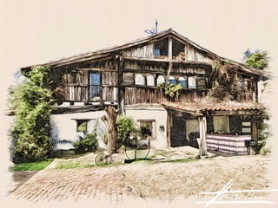
BASERRI TASTING MENU

Dried tomato pate and basil timbale with burrata and black olive oil
Brothy seafood rice with crispy lobster legs
Gyozas stuffed with oxtail and foie gras in a stew sauce

Turbot on aubergine and tomato vinaigrette with Hollandaise foam
Low temperature Iberian pork shoulder with truffle sauce, sweet potato purée and grilled wild asparagus

Cheese, walnuts and quince in different textures with cinnamon ice cream

€62,00 VAT INCLUDED
(This fixed price menu is served to the whole table. Drinks not included)

TRADITIONAL BASERRI TASTING MENU

Cantabrian anchovies in brine with roasted red peppers and olive oil
Codfish omelette with green peppers
Croquettes with two flavours (baby squid and ham)

Grilled rib-eye with roasted red peppers and chips (-+900 g every 2 people)

Goxua with vanilla ice cream

€52,00 VAT INCLUDED
(This fixed price menu is served to the whole table. Drinks not included)

35 aniversario
Urteurrena 1988-2023

